1. Install Java Development Kit (JDK) and configure Environment variable using the below link

<http://www.wikihow.com/Install-the-Java-Software-Development-Kit>

1. Install Maven and configure Environment Variable using the below link

<http://www.mkyong.com/maven/how-to-install-maven-in-windows/>

1. Download Git software from below url

<https://git-scm.com/downloads>

1. Double click the downloaded Git exe file and click “**Next**” till you reach the installation finished message. (Don’t change the default options provided by the Setup)
2. You can also follow the screenshots mentioned in this email attachment for installing Git software if you want.

Note: Tortoise Git software is not needed. Only Git software installation is needed



1. Download the one click installation file of GAgent.exe (**Start_GAgent.exe**)
2. Run the downloaded exe file using the option “**Run As Administrator**”
3. Then the program will create a shortcut on your desktop “**Start-GAgent v2.0**” which can be used for running the GAgent v2.0 software.

Note: The one click setup will automatically run the GAgent software. The shortcut has been provided for you in order to start GAgent v2.0 manually.

1. In order to add GAgent v2.0 to windows startup programs list so that after each login attempt the program will automatically start, please follow the below steps
2. On start menu All Programs list find a folder called Startup and Right click on it and Select Explore All Users option

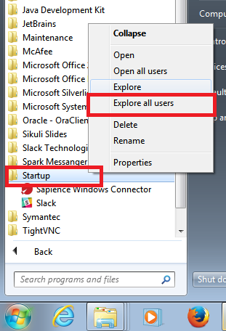

1. One Folder will be opened. Copy paste the shortcut on your Desktop “**Start-GAgent v2.0**” to that folder

